Research of Readout System for CEPC Semi-Digital Hadronic Calorimeter

introduction
After the discovery of the Higgs boson, it is natural to measure its properties as precise as possible. To obtain large number of Higgs boson, collider experiments are essential such as the running Large Hadron Collider (LHC). Besides LHC, scientists are propose to build future high energy collider such as International Linear Collider (LHC), Compact Linear Collider (CLIC), Future Circular Collider (FCC) and Circular Electron Positron Collider (CEPC). Calorimeters play an important role in modern collider system and for hadronic measurement sampling calorimeter is the best choice due to its fine segment and high spatial resolution. For hadronic calorimeter, usually use steel as absorber layer and gas detector or scintillator as active layer.
Simulation results show that for a calorimeter with cell sizes as small as 1×1 cm², simple hit counting is already a good energy measurement for hadrons in the energy range of final state particles for the CEPC. The probability for more than one charged particle hitting the same readout pad in-creases for higher energy, especially in the central region of a shower. A more general calorimeter with multi-threshold readout (e.g.3 thresholds) is therefore also considered, a so-called Semi-Digital Hadron Calorimeter (SDHCAL).
For CEPC HCAL, Gaseous Electron Multipliers (GEM) detector have been proposed for the active layers due to its high efficiency, high rate capability, homogeneity and compactness. The readout pads is sized 1×1 cm², and for entire HCAL the readout channel density might be. So that the data acquisition system must be carefully designed.

READOUT ASIC
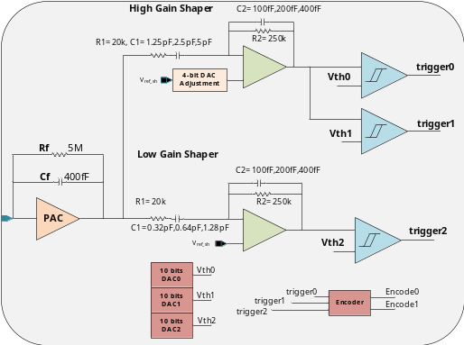
Figure 1 Structure of MICROROC ASIC
An ASIC named MICROROC (MICRO-mesh gaseous structure Read-Out Chip) is chosen to readout such huge channels. MICROROC is a 64 channels readout integrated circuit developed at IN2P3 by OMEGA/LAL and LAPP microelectronics groups. The structure block of MICROROC is shown in figure 1. Each channel of MICROROC is made of a very low noise charge preamplifier, two different adjustable shapers (A high gain shaper for small signal and a low gain shaper for large signal), three comparators for tri-threshold readout and a random access memory used as a digital buffer. Other blocks, like 10-bit DAC, configuration register, bandgap voltage reference, LVDS receiver are shared by 64 channels.

Data Acquisition System

Calibration and Test

Conclusion

Reference:

Ahmad, M. (2015). CEPC-SPPC preliminary conceptual design report, volume I: physics and detector.
Adloff, C., Blaha, J., Chefdeville, M., Dalmaz, A., Drancourt, C., Dulucq, F., ... & Karyotakis, Y. (2012). MICROROC: MICRO-mesh gaseous structure Read-Out Chip. Journal of Instrumentation, 7(01), C01029.

